LAB221 Assignment | Type: | Short Assignment
 | Code: | J2.S.P0107
 | LOC: | 10
 | Slot(s): | 1

Title
Use progress bar in program
Background Context
A progress bar can be used to show a user how far along he/she is in a process.

Program Specifications
Create a program to use JProgressBar.

Function details:
NA

Expectation of User interface:
The screen when the program startup should be as:

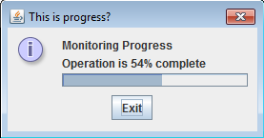

Guidelines

